`

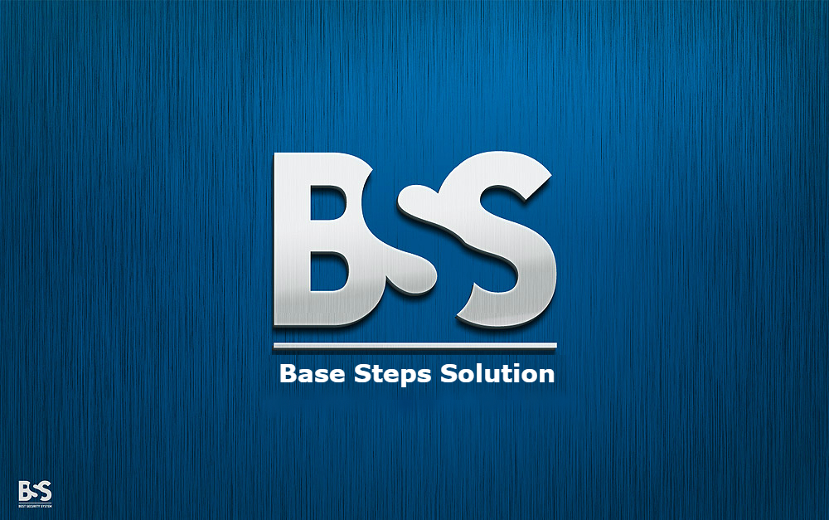

Test Plan

Van Lang Admissions

# Revision Table

|  |  |  |  |
| --- | --- | --- | --- |
| Author | Date | Reason for changes | Version |
| Nguyen Hien | 22/10/2016 | Test plan | 1.0 |
|  |  |  |  |

Table of Contents

Revision Table 1

1. INTRODUCTION 3

1.1. Purpose 3

1.2. Scope 3

1.3. Objectives 3

1.4. Audience 3

2. Process 4

2.1. Process flow 4

2.2. Activities 5

2.3. Test execution process 7

2.4. Roles and Responsibility 7

3. Process’s Method/Metrics 8

Track Testing’s Schedule 8

High Productivity 9

4. Process Tool 9

5. Resource & Environment Needs 9

# INTRODUCTION

## Purpose

This test approach document describes the appropriate strategies, process, workflows and methodologies used to plan, organize, execute and manage testing of software projects within Van Lang Admissions.

## Scope

## The BSS Test Plan defines the unit, integration, system, regression, and Client Acceptance testing approach. The test scope includes the following:

## Testing of all functional, application performance, security and use cases requirements listed in the Use Case document.

## Quality requirements and fit metrics Van Lang Admissions.

## End-to-end testing and testing of interfaces of all systems that interact with the Van Lang Admissions.

## Objectives

* A primary objective of testing application systems is to: assure that the system meets the full requirements, including quality requirements and fit metrics for each quality requirement and satisfies the use case scenarios and maintain the quality of the product.
* The secondary objective of testing application systems will be to: identify and expose all issues and associated risks, communicate all known issues to the project team, and ensure that all issues are addressed in an appropriate matter before release. As an objective, this requires careful and methodical testing of the application to first ensure all areas of the system are scrutinized and, consequently, all issues (bugs) found are dealt with appropriately.

## Audience

The intended audience of the Test Plan is

|  |  |
| --- | --- |
| Intended Audience | Description |
|  |  |
|  |  |
|  |  |
|  |  |
|  |  |

# Process

## Process flow



## Activities

|  |  |  |  |  |  |
| --- | --- | --- | --- | --- | --- |
| No. | Activities | Description | Input | Output | Roles |
| 1 | Requirement Analysis | * Analyze business functionality to know the business modules and module functionalities. * Identify types of tests to be performed. * Gather details about testing priorities and focus. * Identify test environment details where testing is supposed to be carried out. | Requirement Document, Architecture Document |  | Test Leader |
| 2 | Test Planning | * Analyze various testing approaches available. * Finalize on the best suited approach. * Preparation of test plan/strategy document for various types of testing. * Test tool selection. * Test effort estimation. * Resource planning and determining roles and responsibilities. | Requirement Document | Test Plan | Test Leader |
| 3 | Test case Development | * Create test cases. * Review and baseline test cases . * Create test data | Requirement Document, Test Plan | Test Cases, Test Data | Tester |
| 4 | Environment Setup | * Understand the required architecture, environment set-up. * Prepare hardware and software requirement list. * Prepare environment setup checklist. * Setup test Environment and test data | Architecture Document, | Hardware software Environment | Tester |
| 5 | Test Execution | * Execute tests as test plan. * Document test results, and log defects for failed cases. * Update test plans/test cases, if necessary. * Map defects to test cases . * Retest the defect fixes. * Track the defects to closure | Test Cases, Test Plan, Test Data, Hardware software Environment | Test Report | Tester |
| 6 | Test Closure | * Evaluate cycle completion criteria based on - Time, Test coverage , Cost , Software Quality , Critical Business Objectives. * Prepare Test closure report. * Qualitative and quantitative reporting of quality of the work product to the customer. * Test result analysis to find out the defect distribution by type and severity | Test Report | Test Closure Document | Test Leader |

## Test execution process



## Roles and Responsibility

|  |  |
| --- | --- |
| Roles | Responsibility |
| Test Leader | To be involved in the planning, monitoring, and control of the testing activities and tasks ensure everything achieved. |
| Tester | be involved in be the primary people identifying test conditions and creating test designs, test cases, test procedure specifications and test data. |

# Process’s Method/Metrics

### Track Testing’s Schedule

|  |  |  |
| --- | --- | --- |
| Number of actual time/Number of planned time Number of actual time | Description | Compares Actual time working with Planned time |
| Metrics detail | Number of planned time: sum of planned time to finish the task  Number of actual time: sum of real time to finish the task |
| Data Collect | In the project schedule |
| Frequency | Weekly |
| Criteria | Bad: > 1  Normal: 0,9 – 1.  Good: <0,9. |
| Chart Example |  |
| Number of complete task/Number of tasks in the testing | Description | Compares the complete tasks with all the tasks |
| Metrics detail | Number of complete task: The number of tasks have been done until current time  Number of tasks in the project: Sum of tasks in the project. |
| Data Collect | In the project schedule |
| Frequency | Each Phrase |
| Criteria | Bad: <1.  Normal: = 1. |
| Schedule performance index. | Description | The progress of schedule |
| Metrics detail | SPI = BCWP/BCWS or EV/PV.  BCWP: Earn value.  BCWS: Budgeted cost of work schedule. |
| Data Collect | In the project schedule |
| Frequency | Weekly |
| Criteria | Ahead Schedule: >1 => good  Behind Schedule: <1 => bad  Right on schedule: = 1 => normal |

### 

### High Productivity

|  |  |  |
| --- | --- | --- |
| Number of test case / effort | Description | To know the testing productivity of a tester |
| Metrics detail | #Create test case: number of test case created.  Effort: time use to create test cases |
| Data Collect | In testing reports |
| Frequency | Testing phrase |
| Criteria |  |
| Number of Tested test case / effort | Description | To know the testing productivity of a tester |
| Metrics detail | #Tested test case: Number of test case tested.  Effort: Time use to test the test cases |
| Data Collect | In testing reports |
| Frequency | Testing phrase |
| Criteria |  |

# Process Tool

|  |  |  |
| --- | --- | --- |
| No | Name | Description |
| 1 | Microsoft office | Store data, make report, record document |
| 2 | Microsoft Visio | Draw process |
| 3 | Microsoft Visual 2013 | Test tool |

# Resource & Environment Needs